CASE HISTORY, EXAMINATION, DIAGNOSIS AND

TREATMENT PLANNING

DR BHAGYASHREE PATIL I YR PG

CONTENTS

1. Introduction
2. Specific difference between child and adult patient
3. Case history:
4. Definition
5. Vital statistics
6. Chief complaint
7. History of present illness
8. Past medical C dental history
9. Parental history
10. Prenatal , natal, post natal and infancy history
11. Diet history
12. Habits

14.Clinical examination

* General examination
* Extra oral examination
* Intraoral examination

15.Provisional diagnosis 16.Investigations

17. Final diagnosis 18.Treatment plan

19.Conclusion

**A thorough case history and clinical examination of the child dental patient is important in order to:**

* establish a good contact and have knowledge of the child and its parents.
* decide on prescription of radiographic and laboratory investi gations.
* identify possible signs of general conditions and diseases.
* arrive at a proper diagnosis and subsequent appropriate treatment plan.
* Diagnosis is the recognition

of a problem and treatment is its solution. So although there may be several methods of successful treatment, there can be only one correct diagnosis.

**Specific Differences Between Child s Adult** Patient

* Child is a distinct human entity and should never be conside r as just a miniature adult.
* Excessive movement
* Short attention span
* Variable communication
* Physiologic changes due to anxiety and fear reflects what he or she has been told about dentistry.
* Variant anatomy
* Parents attitude must be assessed, their any unpleasant experience may be transmitted to the patient.
* First dental visit projects influence on child’s future behaviour towards dentistry.
* Diagnosis of a patient starts as soon as the patient steps into the clinic.
* One must **Observe** the….
* Appearance
* 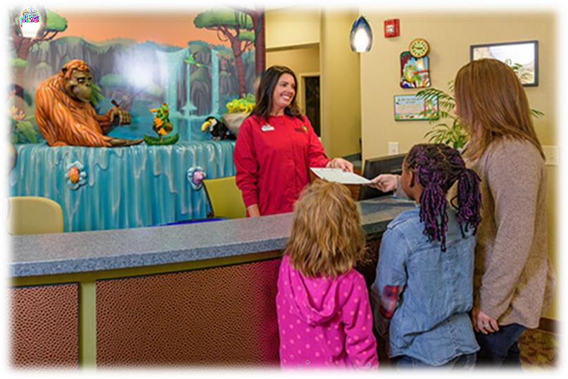

Height

* Built
* Gait
* Attire
* Behavior
* case history can be considered to be a planned professional conversation that enables the patient to communicate his symptoms, feeling and fears to the

clinician.

# OBJECTIVES

* Arrive at a tentative diagnosis for patient’s history.
* Determine any systemic factor that might affect formulation of a diagnosis.
* Determine any systemic condition that requires special precaution prior to/during dental procedures to protect life C health of patient.

# VITAL STATISTICS

* Hospital /Case / OPD no.
* Name
* Age and Sex
* Ethnic group
* School and class
* Address
* Contact no.

# DATE

* Records the time the patient reported and can be referred back during the follow up visits.

# CASE NUMBER

* It is useful for the purpose of maintaining a record, billing the individual and for legal considerations.

# NAME

* A patient usually likes to be called by name.
* This will help to elicit the history properly.
* In case of pediatric patients, addressing the patient by his/her name or pet name will encourage him/her to talk free ly.
* Advantage of knowing the patient names are identification, t o maintain record, communication and

psychological benefit.

# AGE

* Knowing the patient’s age is beneficial to the clinician many ways.
* Chronological age compared with dental and skeletal age ca n be useful in determining growth and development of

a patient.

* *Diagnosis:* Certain diseases are more common at certain ag es

# DENTAL DISEASES PRESENT SINCE BIRTH OR SEEN INFANCY

* **Related to jaw**

Agnathia, Facial hemihypertrophy, Macrognathia, Cleft palate

* **Related to lip**

Commissural pits and fistulae, Double lip, Cleft lip

* **Related to gingiva**

Congenital epulis of the newborn, Fibromatosis gingiva

* **Related to tongue**

Microglossia, Macroglossia, Aglossia, Ankyloglossia, Cleft tongue

, Fissured tongue,

Median rhomboidal glossitis, Lingual thyroid nodule

* **Related to teeth**

early / delayed eruption, partial/ complete anadontia

* **Related to TMJ**

Aplasia or congenital hypoplasia of the mandibular condyle

# SYSTEMIC DISEASES

Congenital heart diseases, Bronchiectasis, Pneumonia

* **Behavior management technique** : In case of pediatric patients, the

dentist has to deal with the child as well as with the parent; hence the approach is 1:2. In talking to a child, the dentist must get down to the patient’s level of understanding based on patient’s intelligence.

* **Drug child dose**

Young rule = (child’s age / age + 12) × adult dose

Clark rule = (child’s age at next birthday / 24 ) × adult dose Diling rule = (age / 20) × adult dose

# SEX

* Some diseases show specific sex predilection. eg :- anorexia is more common in females while hemophilia may be found exclusively in males.
* Girls mature faster than boys thus their treatment may be re quired

earlier.

* Esthetics and emotion is more of a concern in female patients.
* Male patients are more prone to trauma during playing.

Child abuse of which sexual abuse or exploitation is more common in case of females.

# RACE/ETHNIC ORIGIN

* Some diseases have a higher prevalence rate in a particular races and oral hygiene practices may be common in some religions as a cultural habit.

# SCHOOL AND CLASS

* To know the economic status and to communicate with the teacher if necessary.
* It also helps in assessing the IQ of the child and to establish effective communication at his own IQ level.

# ADDRESS AND CONTACT NO.

* It is necessary for future correspondence and scheduling foll ow up

appointments.

* Full postal address of the patient should be taken for future communication.
* A few diseases have got geographical distribution. *Dental caries* and *mottled*

*enamel* are dependent on the fluoride content of the domestic wa ter.

* *Dental caries* is more common in modern industrialized area s while

*periodontal diseases* are more common in rural areas.

# PARENTS EDUCATION AND OCCUPATION

* It is helpful in knowing the attitude and approach of parents towards child’s oral and general health.
* Expensive treatment cannot be given to the patient with low socio-economic status.

# PEDIATRICIAN/ FAMILY PHYSICIAN

* It may be required in case of emergencies or when an advice is needed regarding any medical condition of the patient.

**Definition**

# CHIEF COMPLAINT

* the reason

for seeking the treatment. The chief complaint should be rec orded in the patient’s own words or as described by

the parent and first attention should be given to it.

**Chronological recording**

* Each of these complaints should be recorded in chronologic al order. If few complaints start simultaneously, record them in the order of severity.
* Do not interrupt the patient if possible.

**Significance**

* Chief complaint aids in the diagnosis and treatment planning

**Most common chief complaints**

* Pain
* Loose teeth
* Delayed eruption
* Caries
* Swelling
* Halitosis
* Bleeding gums
* Maligned teeth

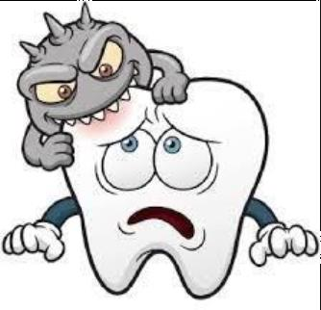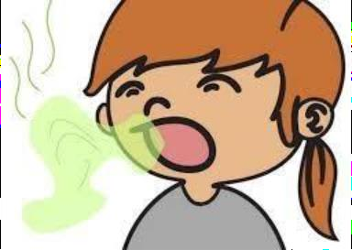

# HISTORY OF PRESENT ILLNESS

* ***Collecting information***
* The history commences from the beginning of the first symptom and extends to the time of examination.
* *Mode of onset*: sudden or gradual, recorded in terms of time, in days, weeks, months, before the current appointment.
* *Cause of onset:* any precipitating factor that results in described symptoms.
* *Duration*: since how long has the complaint has been present.
* *Progress:* intermittent, recurrent, constant, increasing or decreasing in severity.
* Aggravating and alleviating factors
* *Relapse and remission:* If patient has got any similar complaint in the past

**PAST MEDICAL s DENTAL HISTORY**

**PAST MEDICAL HISTORY:-**

* This should include operations, hospitalization,
* infectious disease, immunization, allergies, accidents, blood t ransfusions, etc.
* Any treatment must be postponed if the patient is suffering f rom acute illness such as mumps, chicken pox, etc.
* History of rhinitis, repeated cold, adenoidectomy, tonsillect omy should be carefully examined for evidence of persisting nasal obstruction before undertaking orthodontic treatment with appliance such as oral screen, activator, etc.
* Patients with cardiac defects should be referred to a pediatrician

and antibiotic prophylaxis must be given prior to any treatme nt to minimize the risk of development of subacute bacterial endocarditis (SABE).

* If the child is undergoing anticoagulant therapy, adjustment of anticoagulant dosage may be required.
* Precaution should be taken to avoid contacting communica ble disease.
* Drug allergy or interactions should be noted
* History of psychological problems should be obtained. This will

help in management of the child's behavior during the proce dure.

# PARENTAL HISTORY

* A dental visit of the parent and the treatment

performed would point towards the attitude of the parents.

* Any unpleasant experience may be transmitted unknowingly to the child.
* Any genetic and inherited abnormalities should also be interviewed.

# PRENATAL NATAL AND POST NATAL

NATAL HISTORY



POST-NATAL

History of the mother during her pregnancy period:

* Nutritional disorders
* *Drugs-* Teratogens, tetracycline .
* Viral infections
* *Accidents/trauma:*
* Abnormal fetal position
* Injury to TMJ during forceps delivery can affect growth of the condyle.
* Cyanosis at birth may indicate congenital cardiac defect.
* Rh incompatibility may lead to erythroblastosis fetalis. History of the early infant period

•feeding habits

•nutritional disturbances.

•Trauma, childhood diseases

•Developmental milestones

•History of immunization

# FAMILY HISTORY

It provides some indication of the hereditarily influenced development of the patient.

* Attitude of the parents towards the oral hygiene, health and dentistry has to be assessed as it may be reflected in the behavior of children.
* Infectious diseases in the family such as tuberculosis should be carefully dealt with.
* Genetic disorders may be seen in the child. Hence history of the parents and siblings should be recorded

# DIET HISTORY

* Feeding during infancy- breast milk, bottle, others. The additives and frequency of feeding is of concern here.
* Diet – vegetarian / non- vegetarian
* Present dietary habits – balance diet, snacking in between m eals
* Patient should be asked about his complete diet of the past 24hrs which should include the time of the day when food was taken, type of food, frequency of sugar exposures.

|  |  |  |
| --- | --- | --- |
| **Time of the day** | **Type of food** | **Sugar exposure (yes/no)** |
|  |  |  |
|  |  |  |
|  |  |  |
|  |  |  |

# PERSONAL ORAL HYGIENE HABITS

* Number of times and method of brushing.
* History regarding ‘who’ brushes the teeth is very important especially in children less than 5 years.
* Use of fluoridated of non-fluoridated dentifices.
* *Brush:* Type of brush and how often it is changed.
* Other oral hygiene aids used like flossing, rinses, etc.

# ORAL HABITS

* It includes recording the frequency, intensity, duration of the habits such as finger/thumb sucking, nail biting/lip biting, tongue thrusting, bruxism, mouth breathing, etc.

# SOCIAL HISTORY

* Personality traits-
* Child’s behavior with f r i ends and family
* Attitude towards new experiences
* Preferences of any toy or person to make them feel comfort ablle
* School s i tuation and l earning abilities

**SIGNIFICANCE :**

* Behaviour management
* Rapport with child
* Emotional stability
* determination of developmental dela

# GENERAL PHYSICAL EXAMINATION

* General appearance
* Vital signs
* Stature
* Height and weight
* Gait
* Speech
* Skin
* Hands
* Nails
* Blood pressure
* Temperature
* Respiratory rate
* Pulse

**TYPES OF BODY STRATURES**

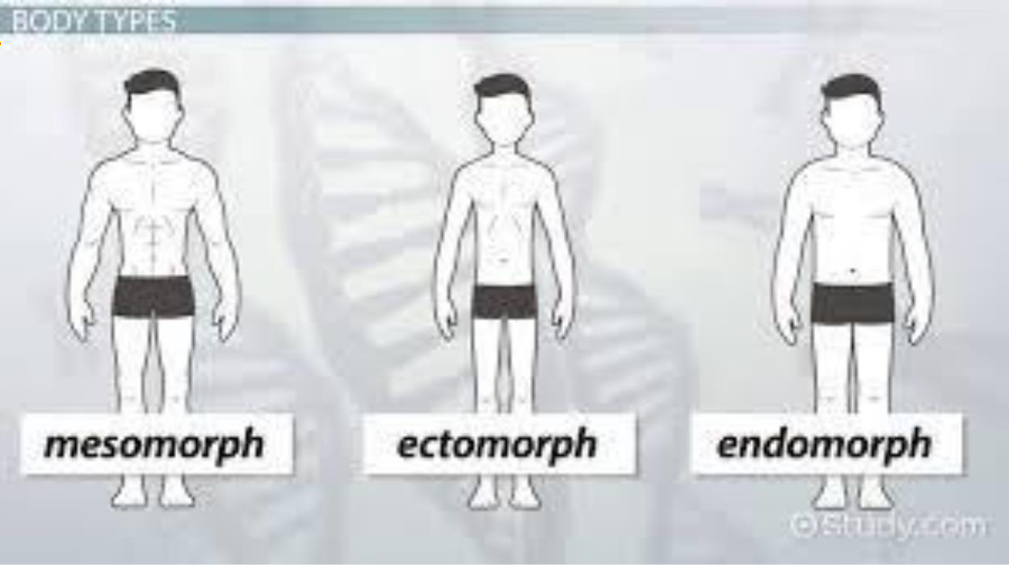

**HEIGHT AND WEIGHT**

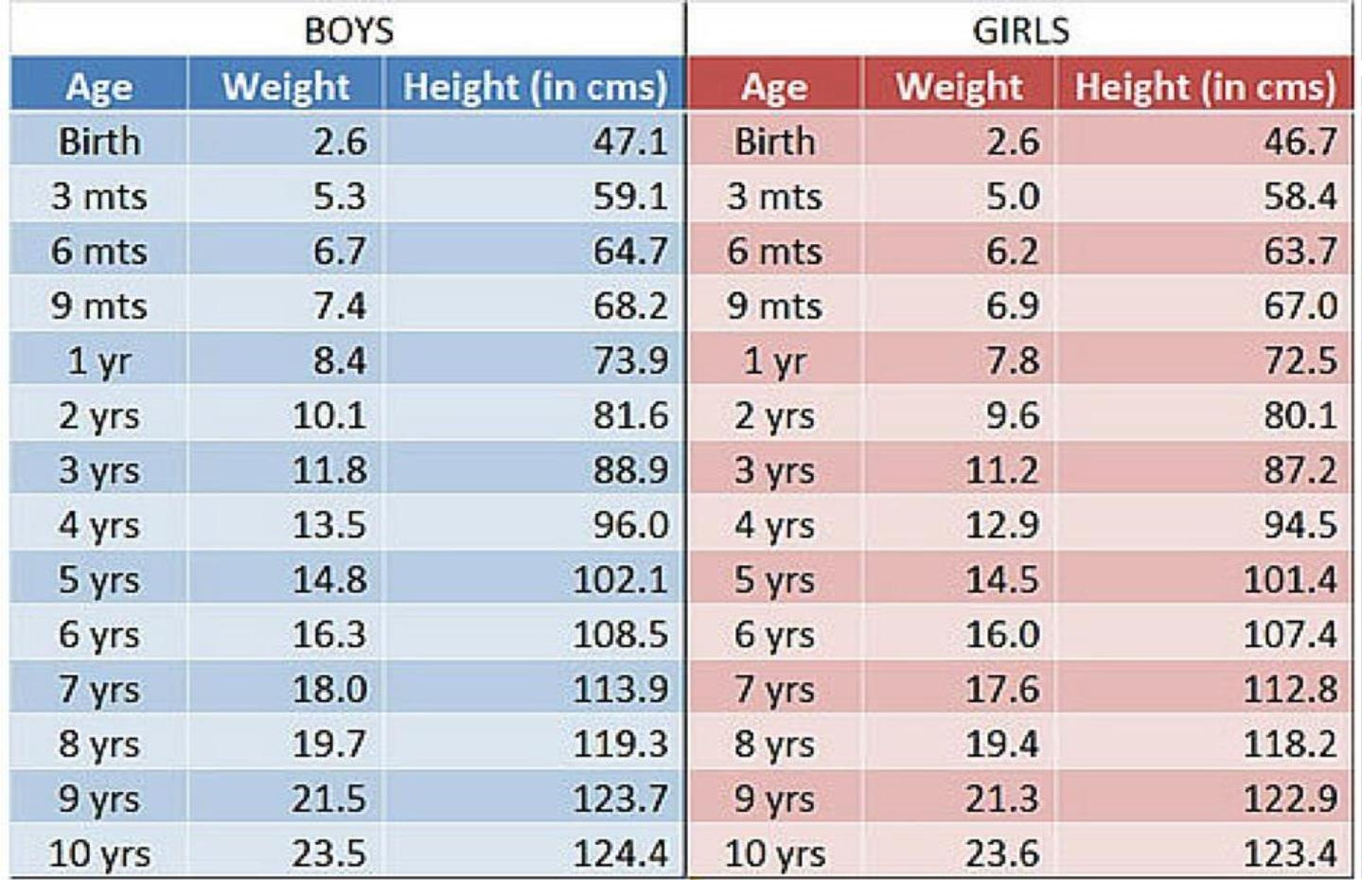

**TYPES OF GAITS**

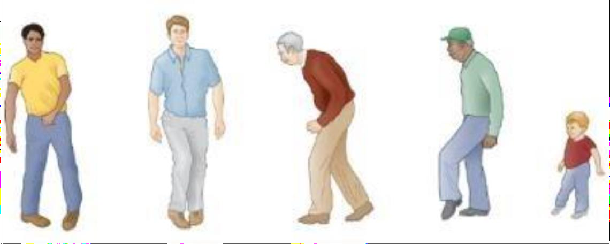

Spastic gait Scissor gait Propulsive gait Steppage gait Waddling gait

# SPEECH DISORDERS

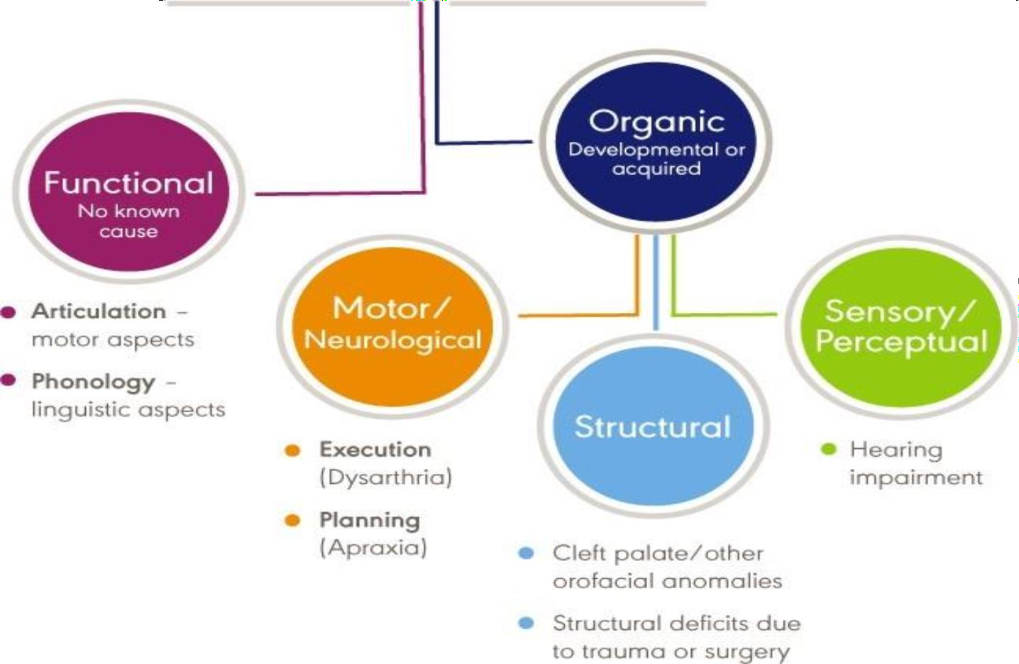

**SKIN**

* *Appearance*—

changes in appearance, rashes, sores, lumps or itching

* *Color—*it is seen for anemia and jaundice.
* *Generalized pallor*—

it is seen in severe anemia. Pallor can be seen in hypopituitarism, shock, syncope, left heart failure.

* *Texture—*

In dehydration, skin is dry and inelastic so that it can be pinched into ridge.

* *Signs*—

such as petechial hemorrhage indicating blood dyscrasias.

* *Eruptions*—

any eruption such as macule, papule, vesicle or bulla.

* *Pigmentation*—

pigmentation of Addison’s disease affects buccal mucous membrane

* *Edema*

# EXAMINATION OF HANDS AND NAILS

THUMB SUCKING CLUBBING OF FINGERS

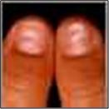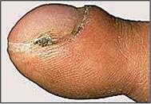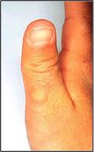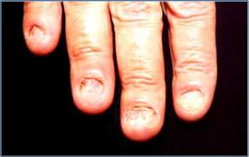KOILONYCHIA

# EXTRAORAL EXAMINATION

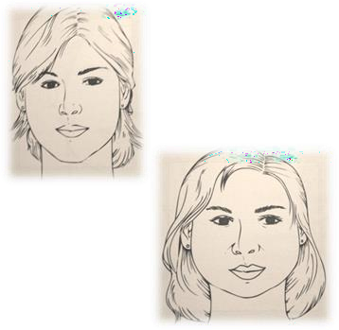SHAPE OF HEAD

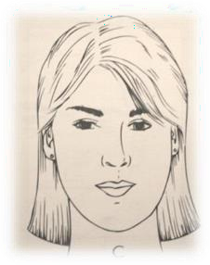

* Mesoprosopic
* Euryprosopic: Broad C Short

TYPES OF HEAD

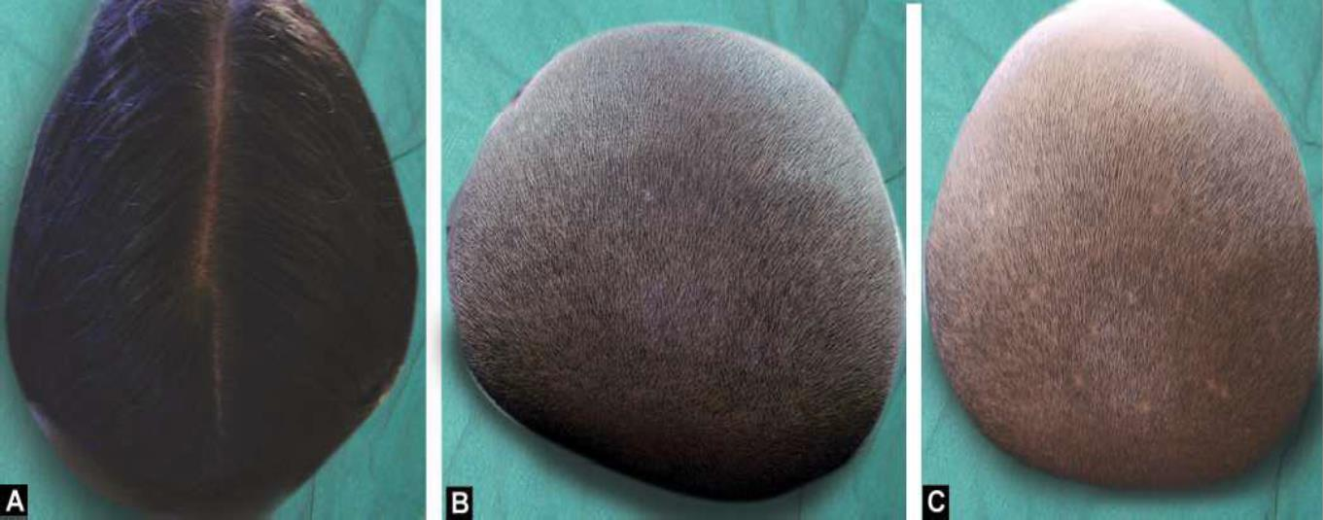

*Dolichocephalic Mesocephalic: Brachycephalic:*

Face profile

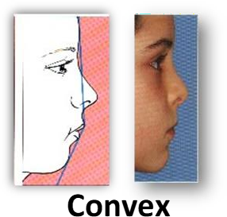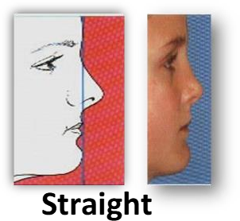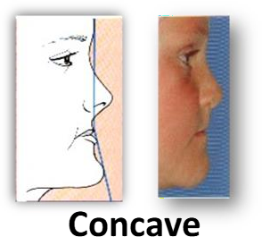

**Extraoral head and neck examination :**-

* The extraoral head and neck soft tissue examination It includes checking for asymmetrical lymph nodes and

temporal mandibular joint examination

* Asymmetries :- In order to check for asymmetries, the clinician will stand in front of the patient to observe the head and neck, focusing on the area around the jaws. If a

significant asymmetry exists, the clinician should ask the patient for any known causes, such as previous surgeries, scars, tumors, and infections.

* Lymph node examination :- To examine the head and neck lymph nodes and other soft tissue of the oral region, the clinician palpates the area of lymph nodes gently to look for tenderness or enlargements. Normal lymph nodes are either not palpable, or may feel like a pea or lentil, and are not tender when touched. Abnormal lymph nodes are generally larger, may be tender, and can be an indication of an inflammation or drainage of infection has occurred.

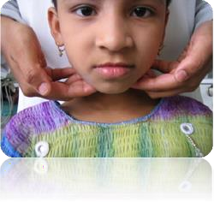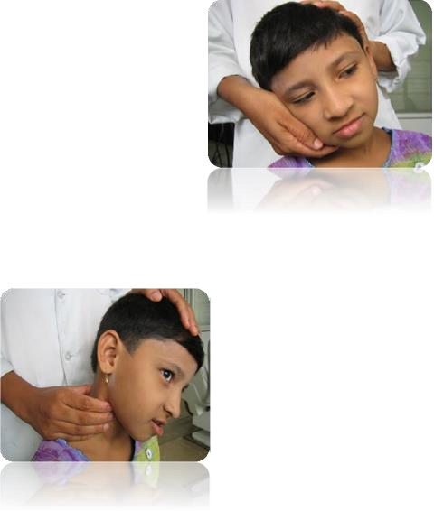

**TMJ examination** :- An examination of temporomandibular joint may also be performed at the initial dental appointment.

This is done by placing the fingertips over the joints with gentle pressure.

The clinician note any tenderness, swelling or redness. Then the patient is asked to open and close his or her mouth slowly, few times.

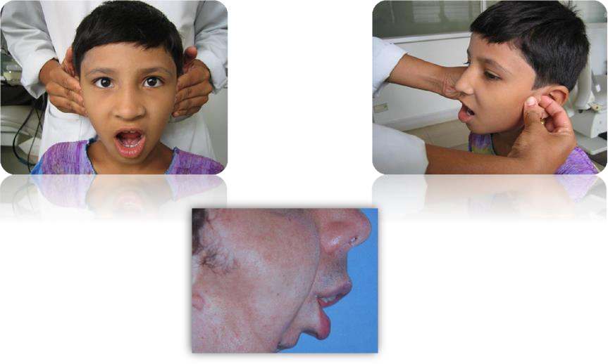He or she may also be asked to slowly move the lower jaw from side to side. If an abnormality is noted, further examination is

I**ntra Oral Examination Position For Infants**

* The infant is positioned on the parents lap facing the parent , with one leg wrapped around each side of the parent.
* The child’s head is lowered on

to a pillow on the operator’s lap for the examination. This

position offers the dentist good stability of the child’s head, while the parent is responsible for the arms and legs.

* It is important to note that proper stability of both head and body

is necessary to carry out a safe oral examination on an infant

, and the parent must be aware of his/her role for this to occur.

* Before beginning the examination it is important to counsel the

parents that their child will likely cry and to reassure them th at this is expected and normal. In fact, if the baby does cry, his/her open mouth will facilitate the intraoral examination.

If the child will not open his/her mouth, a finger can be

placed high and posterior to the most posterior tooth (in the lateral pterygoid region) to facilitate a jaw-opening reflex.

* The dentist should thoroughly assess the infant’s overall growth and development, extra-oral tissues and intra- oral soft tissues and teeth.

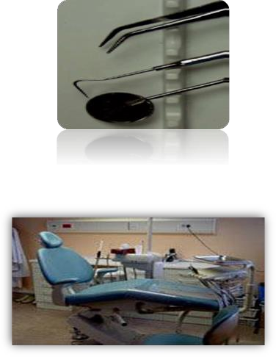

# ARMAMENTARIUM

Mouth mirror

* Explorer
* Tweezers
* Periodontal probe
* Cotton rolls

INTRAORAL EXAMINATION

* The intraoral soft tissue examination includes checking the soft tissues of the mouth, the throat, the tongue and

the gingiva.

* The labial mucosa will be examined by gently turning the lip out. It should appear wet and shiny. Scars inside the lower lip are seen frequently as a result of trauma as a child

# ANOMALIES

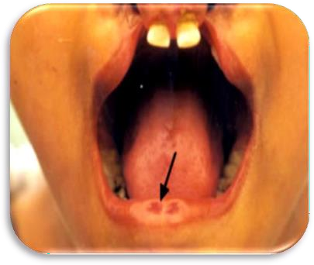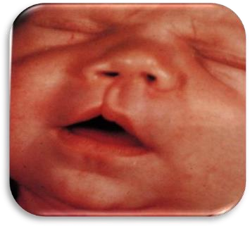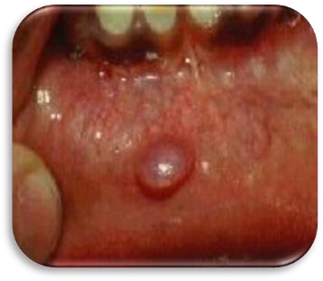

**LIP PITS CLEFT VESICULO BULLOUS LESIONS**

**Buccal mucosa and vestibular mucosa**

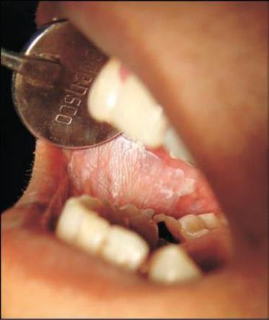

* Examine the inside of the cheek for

aphthous ulcer, leukoplakia, mucous cyst, lipoma, mixed salivary tumor, papilloma and carcinoma.

* Pigmented patches are seen in Addison’s disease and in Peu tz Jegher’s

syndrome.

* White lesion can be seen in pronounced linea alba, leukoedema, hyperkeratotic patches.

BUCCAL MUCOSA

Normal variants of the mucosa

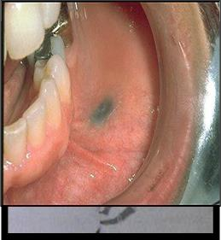

Palpate bi-digitally for swellings and ulcerations

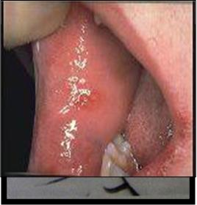

**Hard and soft palate**

* congenital cleft, perforation,

ulceration,swelling, fistulae, papillary hyperplasia, tori, recent burns and hyperkeratinization.

* In case of congenital cleft, note the
* extent of the cleft (involving only the uvula, only the soft palate or part or whole of the hard palate).
* Whether the nasal septum is hanging free or attached to one side of the cleft.
* A scar of the operation hole may

persist after an operation for closure of congenital cleft.

SOFT AND HARD PALATE

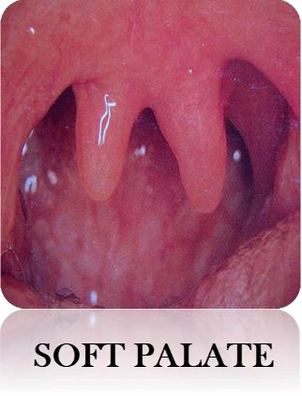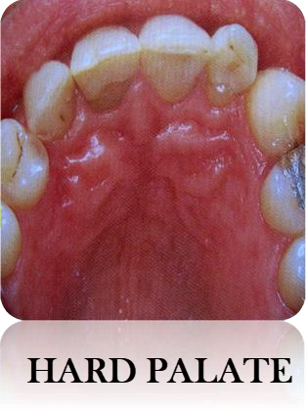

# TONGUE

Color Size Appearance Coating

Range of movements Atrophy Deviation

To check mobility

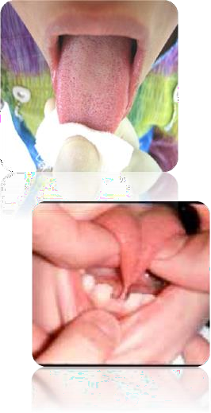

FRENAL ATTACHMENT

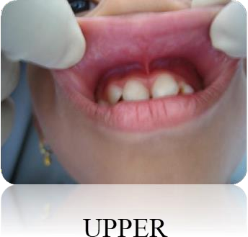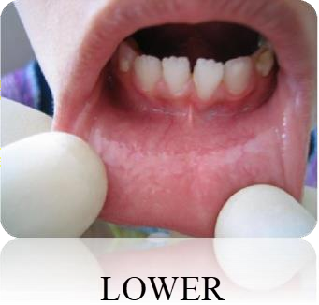

EXAMINATION OF GINGIVA

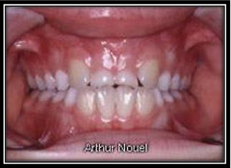

GINGIVAL SWELLINGS

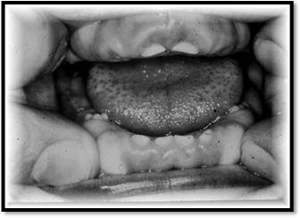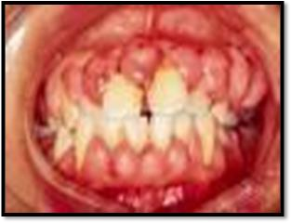

TONSILS

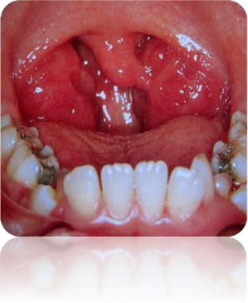INFLAMATION

# EXAMINATION OF TEETH

Stages of development

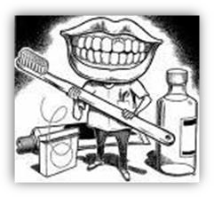

Number, size, shape and color Occlusion Oral hygiene status Palpate for mobility

Transillumination for fractures C interproximal caries Percussion for periapical pathosis

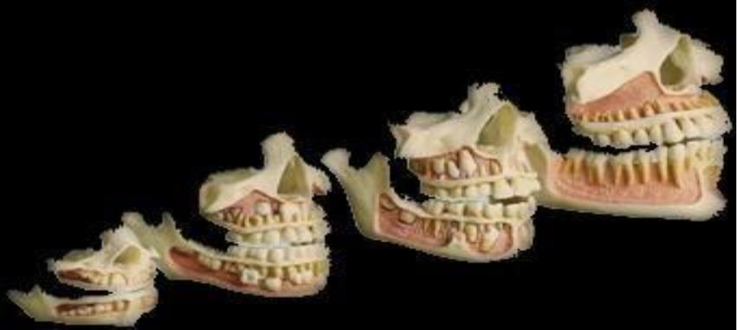

SIZE C SHAPE OF TEETH

* ​

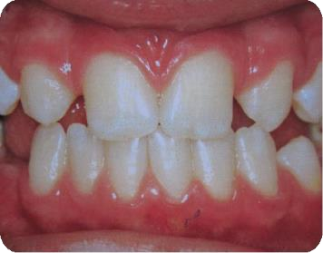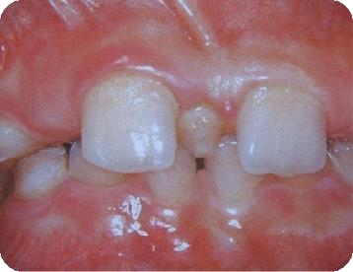

Macrodontia

* True and relative

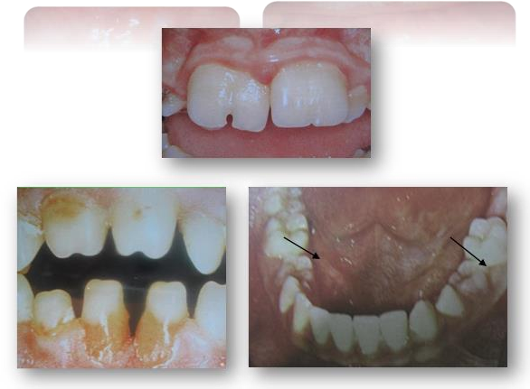

Microdontia

True and relative Shape Cone, peg shaped Gemination

**EXTRINSIC STAINS**

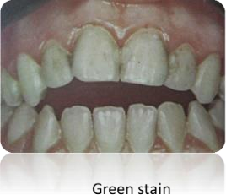

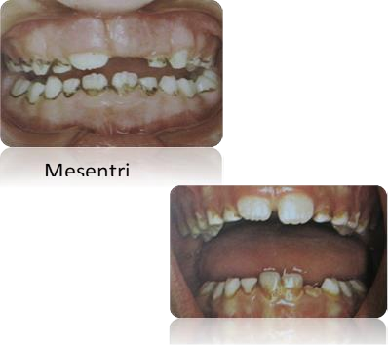

Orange stain

**INTRINSIC STAAIN**

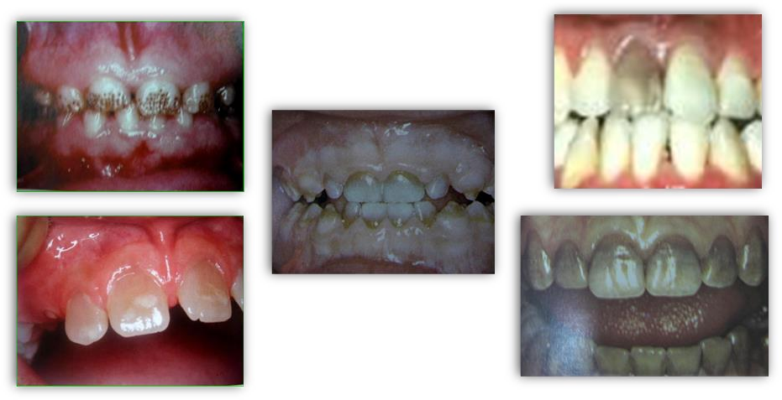

Amelogenesis imperfecta Pulpal necrosis

**Tetracycline stains**

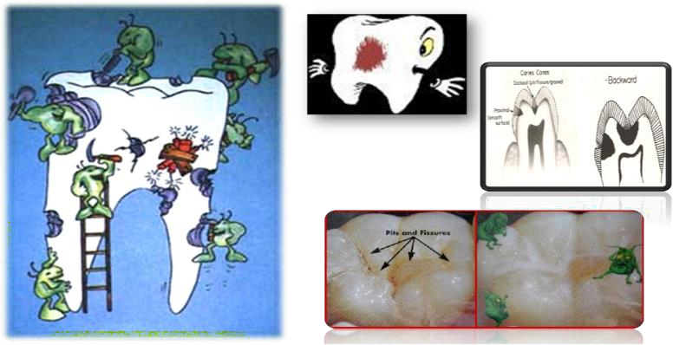

CARIES ORTHODONTIC EVALUATION

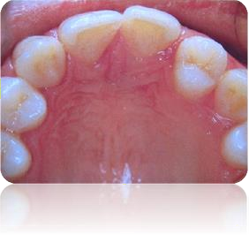

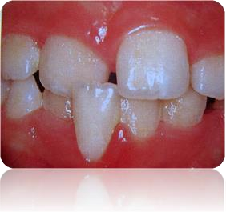Sequence C Eruption Of Teeth

Malposed Individual Teeth

ARCH FORM

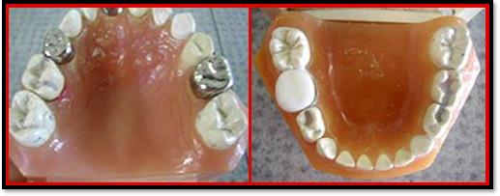

OCCLUSION ANALYSIS

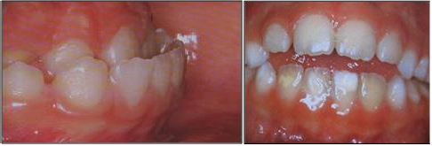

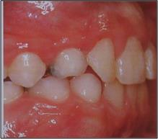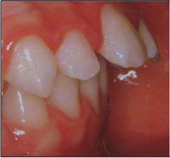

CLASS 1

CLASS 2

CLASS 3 CROSS BITE

OVER BITE OVER-JET

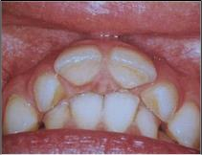

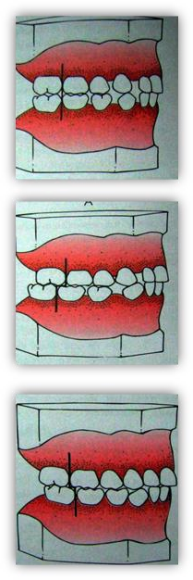

POSTERIOR SEGMENT

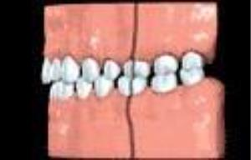

Flush terminal plane

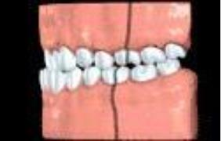Mesial step

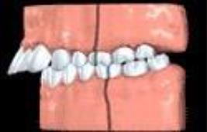 Distalstep

**Oral Diagnosis :** discipline of dentistry that is specifically

concerned with the art C science of health assessment. The process where by the data obtained from questioning, examining C testing are combined by the dentist.

# DIAGNOSIS

The art or act of identifying a disease from its signs and symptoms

# PROVISIONAL DIAGNOSIS

Provisional diagnosis is a general diagnosis based on clinical impression without any laboratory.

# DIFFERENTIAL DIAGNOSIS:

It is the evaluation of the subjective sensation [symptoms] C objective manifestations of simil

# INVESTIGATIONS

* Percussion
* Radiographs:

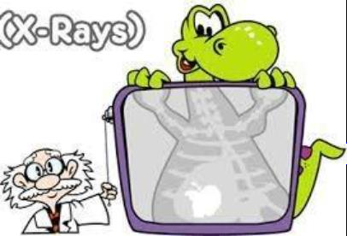

* Intra Oral: IOPA , Bite Wing, occlusal
* Exta Oral:
* Cephalogram
* Lateral cephalogram
* Orthopantomogram
* Handwrist etc.
* Cone beam tomography
* Pulp testing
* Study Models
* Photographs
* Hematology screening
* Histopathological examination

# TREATMENT PLAN

* The chief complaint must be addressed and treated.
* All oral health care must be related to systemic conditions and treatment of these conditions.
* Existing disease must be eliminated and new disease preven ted.
* The effect of past treatment should be considered
* The social and economic history of the patient should be co nsidered
* **Systemic phase**: Premedication (antibiotic prophylaxis)
* **Preventive phase**: Caries risk assessment.
* Assessment of preventive measures like fluoride application,
* pit and fissure sealants, diet counseling.

**Preparatory phase:**

* Behavior management.
* Oral prophylaxis.
* Caries control.
* Orthodontic consultation.
* Oral surgery.
* Endodontic therapy
* Corrective phase:
* Restorative dentistry.
* Prosthetic Rehabilitation.
* Early orthodontic intervention.
* Maintenance phase:
* Frequency depends on child’s initial needs, success of
* therapy, parental cooperation

# INFORMED CONSENT

* The informed consent process is a detailed process of infor ming the patient or the custodial parent or, in the case of minors, legal guardian regarding the diagnosis and treatment required and the associated problems that might be encountered. They should also be told about alternate treatment plan if any.
* It also allows them to make educated decision and participate and retain autonomy over the health care received. Informed consent

also may decrease the practitioner’s liability from claims ass ociated with miscommunication.

* A written form should be used with the required information andsigned by the child’s guardians. Consent forms should b e procedure specific, with multiple forms likely to be used.
* It is also important to discuss the behavior management tec hnique that will be used and prior written consent taken for the same.
* Items appearing on a consent form should include:
* Name and date of birth of patient;
* Description of specific treatment in simple term.
* Alternatives to treatment.
* Potential adverse sequelae specific

# CONCLUSION

* The provision of dental care for children presents some of the greatest challenges (and rewards) in clinical dental practice.
* High on the list of challenges is the need to devise a comprehensive yet realistic treatment plan for these young patients.
* Successful outcomes are very unlikely in the absence of thorough short- and long-term treatment planning.
* Furthermore, decision-making for children has to take into account many more factors than is the case for adults.
* Hence an elaborate case history taking is of utmost importa nce.

# REFERENCES

1. Cameron AC, Widmer RP. Handbook of Pediatric Dentistry E- Book. Elsevier Health Sciences; 2013 Jul 10.
2. Dean JA, editor. McDonald and Avery's Dentistry for the Chil d and Adolescent-

E-Book. Elsevier Health Sciences; 2015 Aug 10.

1. Longhurst P. Pediatric dentistry: Total patient care: Stephen HY Wei. Pp. 615. 1988. Beckenham, Quest Meridien. Hardback,£ 34· 06.
2. Mathewson RJ, Primosch RE. Fundamentals of pediatric den tistry. Quintessence Books; 1995.
3. Rapp R, Winter GB. A colour atlas

of clinical conditions in paedodontics.

Mosby; 1979.

1. Glick M. Burket's oral medicine. PMPH USA; 2015.
2. White GE. Clinical oral pediatrics. Quintessence Pub Co; 19 81.
3. Forrester DJ, Wagner ML, Fleming J, editors. Pediatric dental medicine. Lea C

Febiger; 1981.

1. Tandon S. Textbook of pedodontics. Paras Medical Publisher

; 2009.

THANK YOU